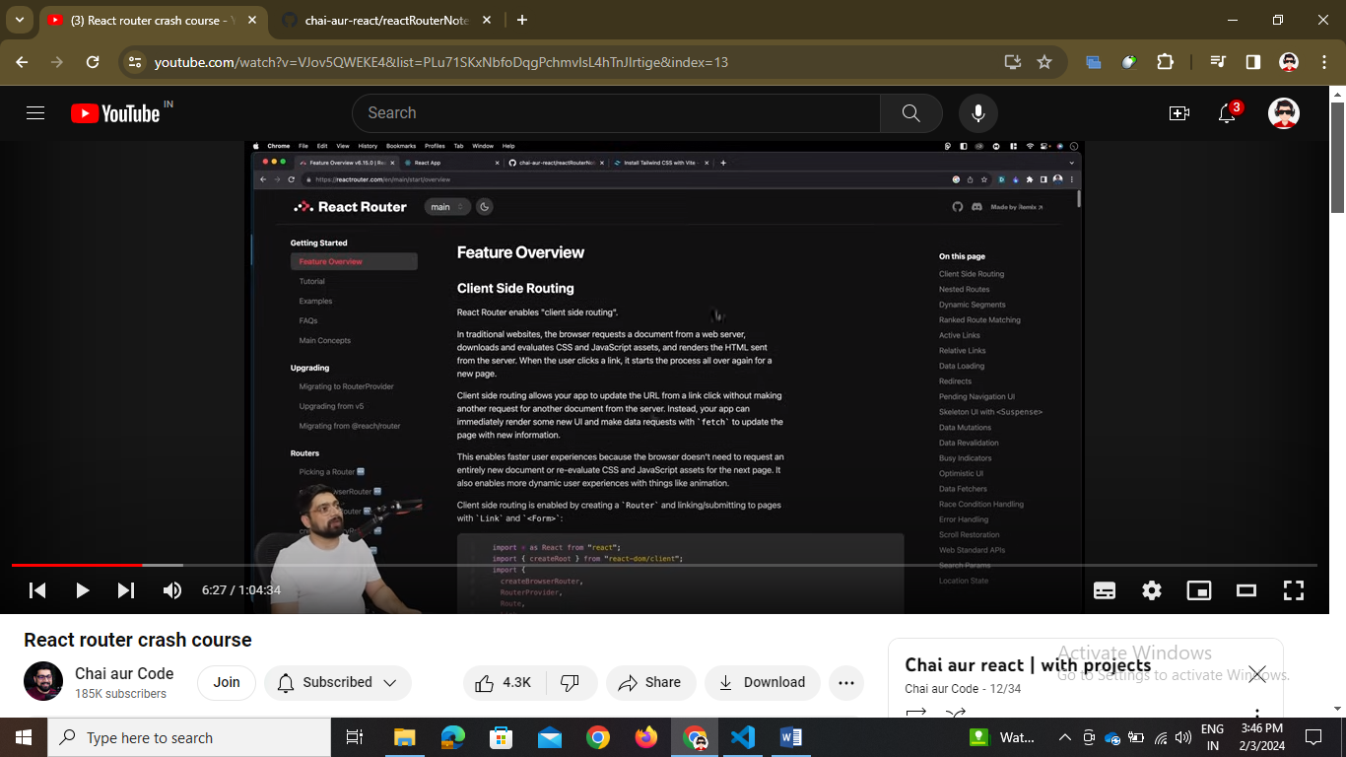

// npm i react-router-dom

{/\* link tag is used instead of a tag as a tag does reloading of page  link tag is with to="" attribute \*/}

Link tag is instead of “a” tag we should not use “a” tag in react

// navbar create karne ka method hai ye 🡪 isme NavLink use hota hai

<ul className="flex flex-col mt-4 font-medium lg:flex-row lg:space-x-8 lg:mt-0">

              <li>

                <NavLink

                  className={({ isActive }) =>

                    `${

                      isActive ? "text-orange-700" : "text-gray-800"

                    } block py-2 pr-4 pl-3 duration-200 border-b border-gray-100 hover:bg-gray-50 lg:hover:bg-transparent lg:border-0 hover:text-orange-700 lg:p-0`

                  }

                >

                  Home

              </NavLink>

        </li>

    </ul>

import { BrowserRouter } from "react-router-dom";

<BrowserRouter>

      <App />

    </BrowserRouter>

// to use link and navlink tags we have to surround app tag inside BroswerRouter like this in the main.jsx file

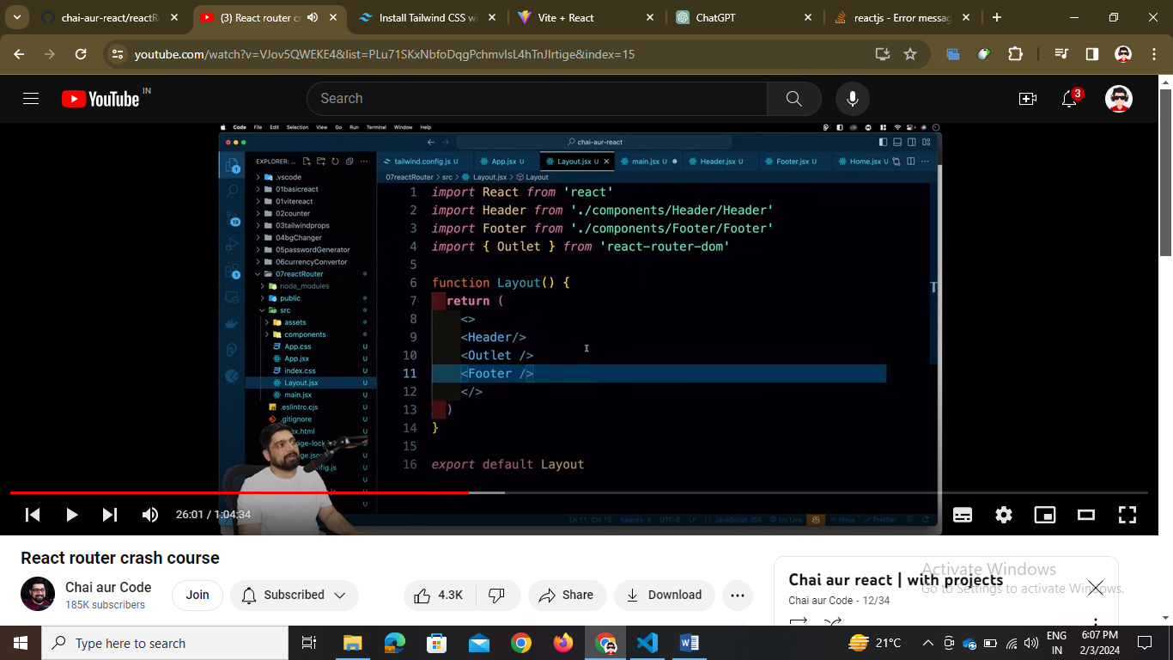

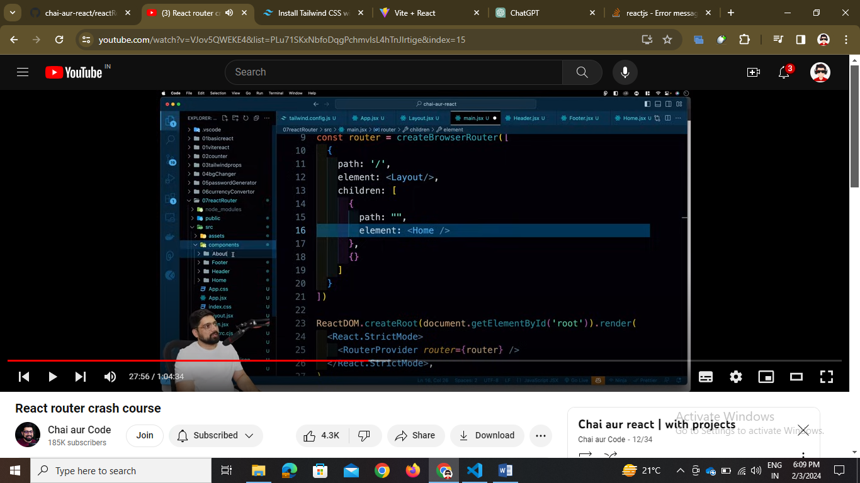

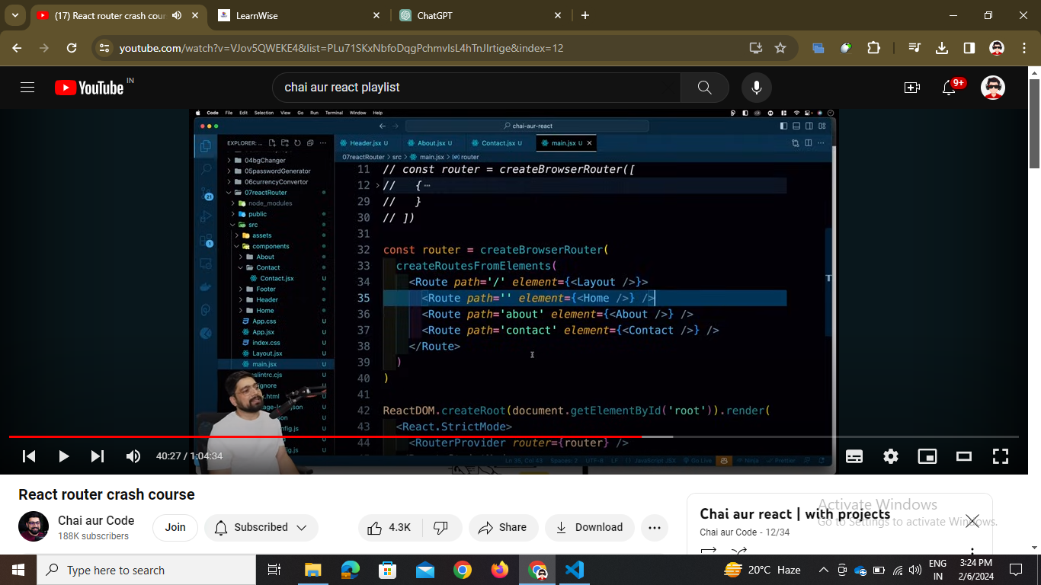// second way is by routes …

<Router>

  <Routes>

    <Route path="/" element={<Home />} />

    <Route path="/about" element={<About />} />

    <Route path="/contact" element={<Contact />} />

  </Routes>

</Router>

// third way of routing

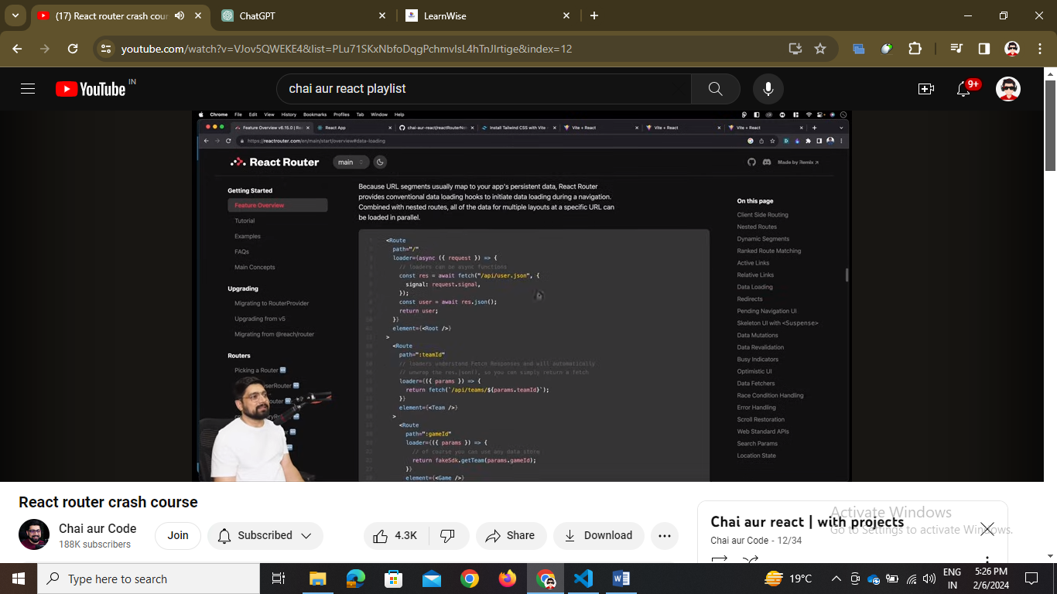

// data loaders -🡪 in this we can load the fetch api directly in the hover part 🡪 but not working

1. Layout
2. React-router dom methods – 3
3. ID using useParams()
4. Api calls optimize 🡪 loader and useEffect